Sofware Implementation

User Manul

Group 6

The Isabelle’s dayspa Management system is a desktop application intended for the employees of the same establishment. It’s purpose is to provide a more efficient manner to conduct day to day business transactions from a single system. It will be able to store customer’s information and other transaction the employees do through out the day such as making appointments and receiving payment.

* Login interface

This interface is shown upon starting the application. User are required to enter valid data before being able to continue

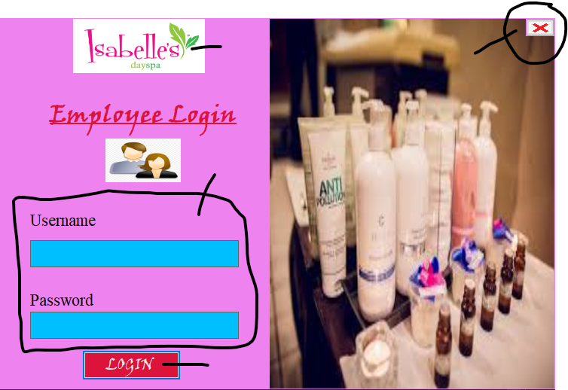

4.

3

2

1.

1. Company logo
2. Button: Used to CLOSE and EXIT application
3. Textbox: Enter employees CREDENTIALS given by Admin
4. Button: Click after user enter correct LOGIN DETAILS

If login SUCCESSFUL user will be notified and moved to the next form

Error occurs if USERNAME or PASSWORD is incorrect or missing

If user receive error re-enter credentials and try again

* DASHBOARD INTERFACE

View after login is successful

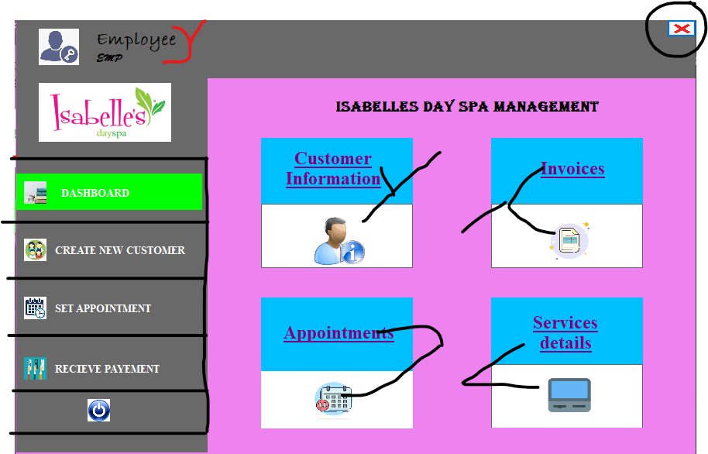

2.

8.

7.

6.

5.

4.

3.

1.

1. Displays User NAME along with User LOGINNAME
2. Button: Used to CLOSE and EXIT application
3. Menu List: Highlight colour green shows that current form ACTIVE also it remains users where they are.
4. Submenu: CLICK on LABEL or ICON to VIEW All Customer or SEARCH for a specific customer
5. Submenu: CLICK on LABEL or ICON to VIEW All Invoices or SEARCH for a specific customer
6. Submenu: CLICK on LABEL or ICON to VIEW All Appointments or SEARCH for a specific customer
7. Submenu: CLICK on LABEL or ICON to VIEW All Service Details or SEARCH for a specific customer
8. Button: Used to LOGOUT or SIGNOUT users to the login in screen

CUSTOMERS EDIT INTERFACE

On this interface users are able to view all current customers or search for a customer they are able to remove or make changes to the database.

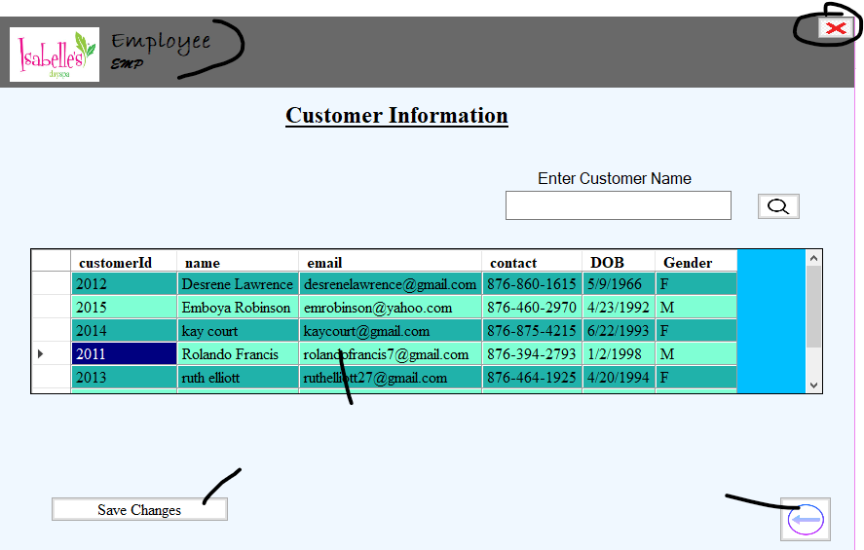

6.

4.

3.

5.

2.

1.

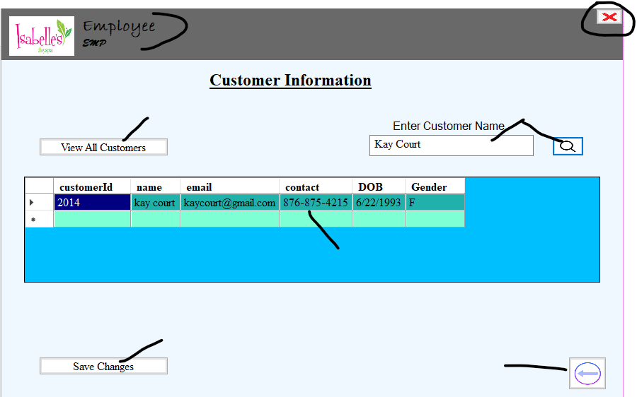

8.

7.

6.

5.

2.

1.

3.

1. Displays User NAME along with User LOGINNAME
2. Button: Used to CLOSE and EXIT application
3. Search Bar: Enter CUSTOMER NAME Then CLICK on magnifying class to SEARCH for a specific customer.
4. DataGridView: Tabular VIEW of all customers you are able to EDIT, DELETE, ORDER customer

If customer FOUND information is DISPLAYED

If customer DOES NOT EXIT an EMPTY gridview will be presented

1. Button: Used as a GO BACK button. CLICK to go back to Dashboard
2. Button: Use to SAVE chnages made to the Database
3. Buttom: Purpose is VIEW all customer after again.
4. DataGridView: Tabular VIEW of searched customer you are able to EDIT, DELETE, ORDER customer information with one click.

INVOICE EDIT INTERFACE

Users are able to view all invoice and search by name, its purpose is to help customers who may have for forgotte their appointment id or date by providing a fast retrieval window.

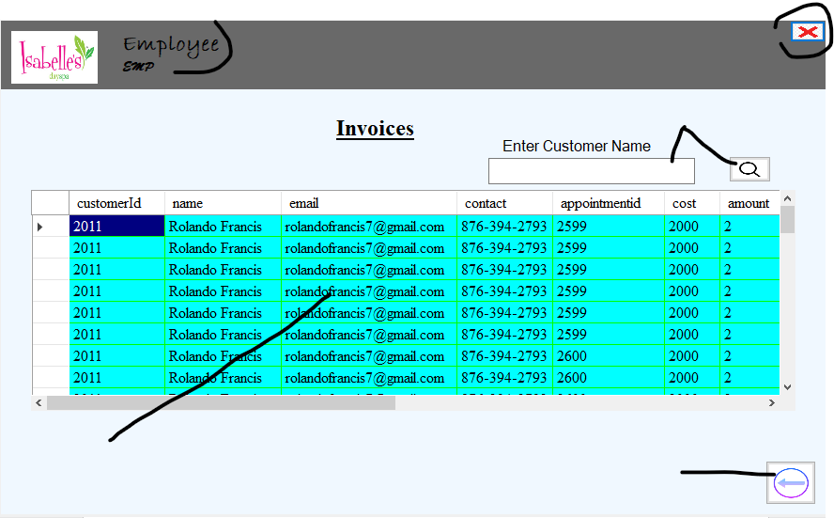

1.

2.

3.

4.

5.

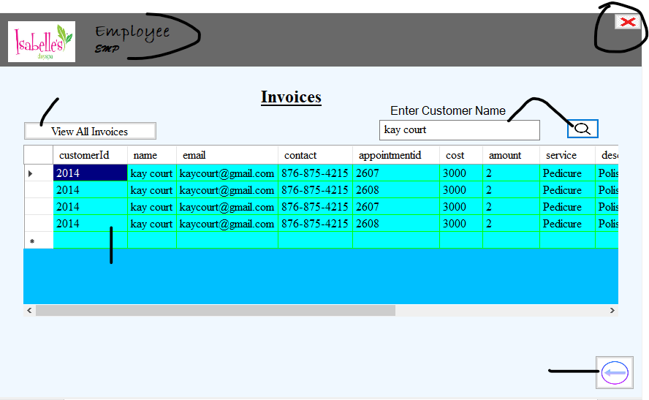

5.

7.

3.

6.

2.

1.

1. Displays User NAME along with User LOGINNAME
2. Button: Used to CLOSE and EXIT application
3. Search Bar: Enter INVOICE NUMBER Then CLICK on magnifying class to SEARCH for a specific invoice .
4. DataGridView: Tabular VIEW of all invoices you are able to ORDER details

If invoice FOUND information is DISPLAYED

If inoice DOES NOT EXIT an EMPTY gridview will be presented

1. Button: Used as a GO BACK button. CLICK to go back to Dashboard
2. Buttom: Purpose is VIEW all customer after again.
3. DataGridView: Tabular VIEW of searched invoices you are able to ORDER invoice information with one click.

APPOINTMENT EDIT INTERFACE

On this interface users are able to view all current appointment or search for a customer they are able to remove or make changes to the database.

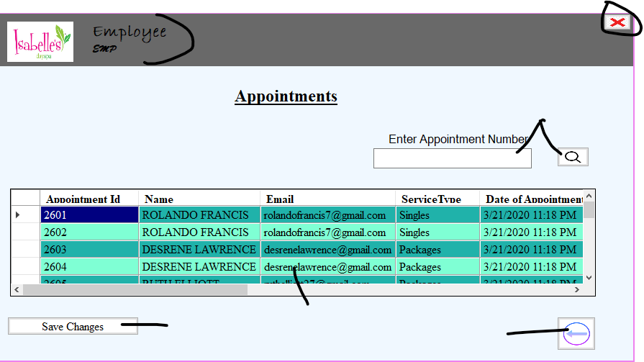

6.

2.

1.

5.

4.

3.

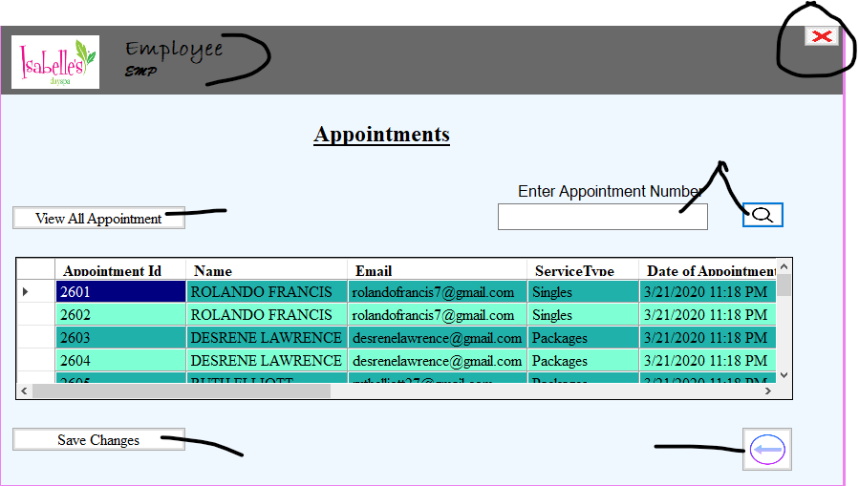

7.

6.

8.

5.

3.

2.

1.

1. Displays User NAME along with User LOGINNAME
2. Button: Used to CLOSE and EXIT application
3. Search Bar: Enter APPOINTMENT NUMBER Then CLICK on magnifying class to SEARCH for a specific invoice .
4. DataGridView: Tabular VIEW of all appointment you are able to EDIT, DELETE, ORDER details

If invoice FOUND information is DISPLAYED

If inoice DOES NOT EXIT an EMPTY gridview will be presented

1. Button: Used as a GO BACK button. CLICK to go back to Dashboard
2. Button: Use to SAVE chnages made to the Database
3. Buttom: Purpose is VIEW all appointments after again.
4. DataGridView: Tabular VIEW of searched appointment you are able to EDIT, DELETE, ORDER appointment information with one click.

SERVICE EDIT INTERFACE

Users are able to view all Service details and search by name, its purpose is to help technician who may have trouble with their appointments system or date by providing a fast retrieval window.

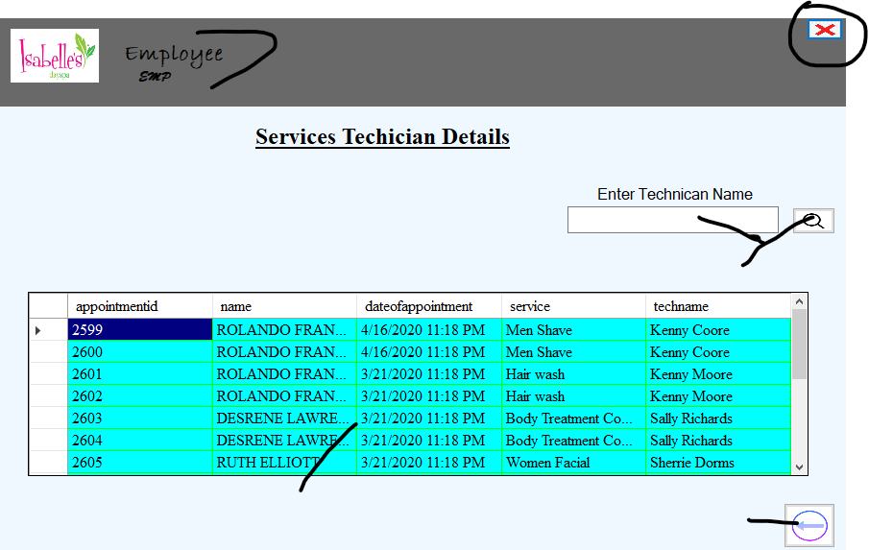

**5.**

**6.**

3.

2.

1.

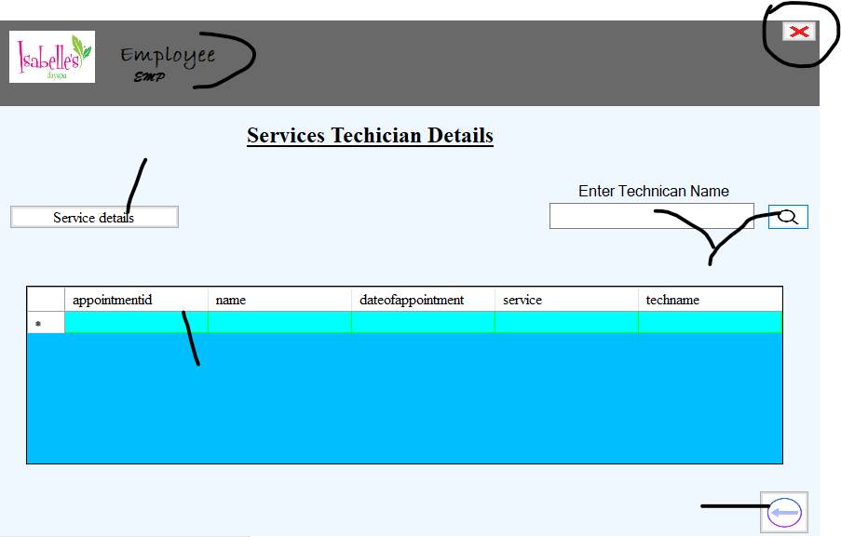

**5.**

**7.**

**3.**

**6.**

**2.**

**1.**

1. Displays User NAME along with User LOGINNAME
2. Button: Used to CLOSE and EXIT application
3. Search Bar: Enter TECHNICAN NAME Then CLICK on magnifying class to SEARCH for a spefic service details .
4. DataGridView: Tabular VIEW of all service details you are able to EDIT, DELETE, ORDER details

If invoice FOUND information is DISPLAYED

If inoice DOES NOT EXIT an EMPTY gridview will be presented

1. Button: Used as a GO BACK button. Click to go back to Dashboard
2. Buttom: Purpose is VIEW all service details after again.
3. DataGridView: Tabular VIEW of searched technican you are able to EDIT, DELETE, ORDER service information with one click.

ADD CUSTOMER INTERFACE

User can use the interface after selecting create customer on the menu list. They are able to add customers

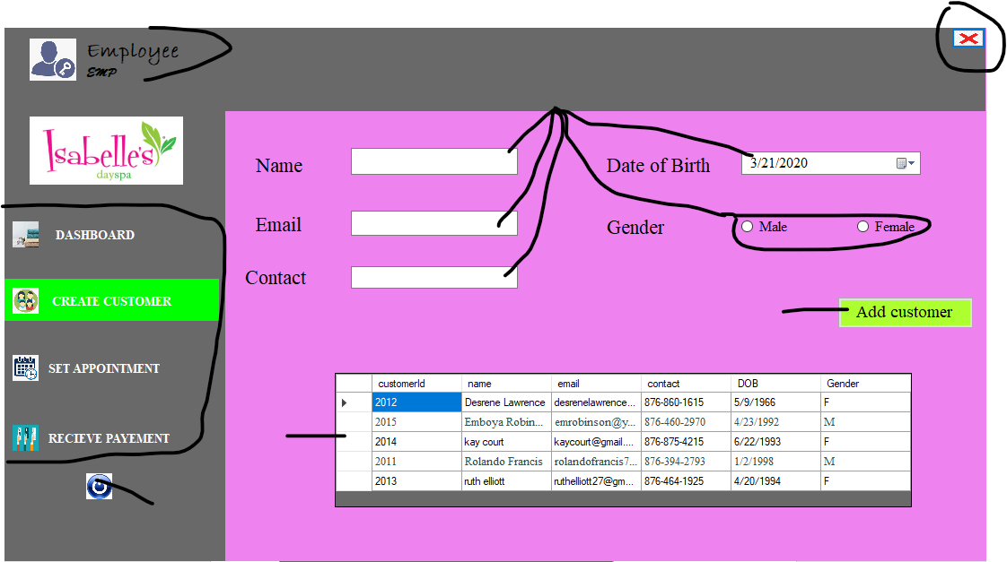

**3.**

**7.**

**6.**

**5.**

**4.**

**2.**

**1.**

1. Displays User NAME along with User LOGINNAME
2. Button: Used to CLOSE and EXIT application
3. Menu List: Highlight colour green shows that current form ACTIVE also it remains users where they are.
4. Textbox: Enter INFORMATION about Customer, CLICK on the calendar icon for a DROPDOWN CALENDAR Navigate to select date. CLICK the radius to select gender.
5. Button: CLICK after customer information is entered.

If SUCCESSFUL application will notify user of success

ERROR occurs if customer information such as email and name is blank to SOLVE this complete the customer form.

1. READ only datagrid view.
2. Button: Used to LOGOUT or SIGNOUT users to the login in screen

MAKE APPOINTMENT INTERFACE

Users able to add a new appointment for exiting Customers

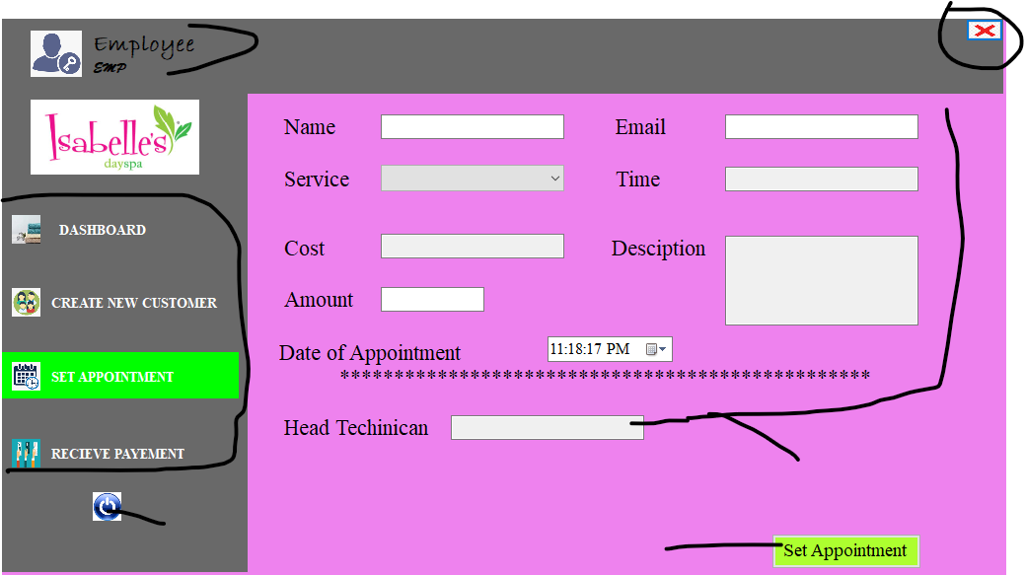

**5.**

**4.**

**6.**

**3.**

**2.**

**1.**

1. Displays User NAME along with User LOGINNAME
2. Button: Used to CLOSE and EXIT application
3. Menu List : Highlight colour green shows that current form ACTIVE also it remains users where they are.
4. Textbox: Enter INFORMATION about Customer, CLICK on the down arrow icon for a DROPDOWN LIST Navigate to select service. Based on Service SELECTION Time, Cost, and Description will AUTO FILL
5. Button: CLICK after customer appointment information is entered.

If SUCCESSFUL application will notify user of success

ERROR occurs if customer information such as email is blank or customer email does not exist to SOLVE this complete the customer form.

ERRORS occur if customer does not exist in customer database

1. Button: Used to LOGOUT or SIGNOUT users to the login in screen

PRINT INVOICE INTERFACE

Interface use to print invoices

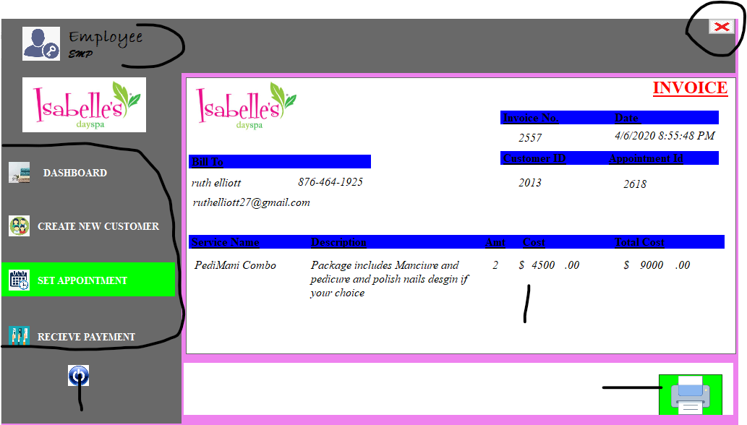

**1.**

**5.**

**4.**

**6.**

**3.**

**2.**

1. Displays User NAME along with User LOGINNAME
2. Button: Used to CLOSE and EXIT application
3. Menu List: Highlight colour green shows that current form ACTIVE also it remains users where they are
4. Invoice Generated after appointment is successful
5. Button: Click icon to PRINT INVOICE
6. Button: Used to LOGOUT or SIGNOUT users to the login in screen

SALES RECIEPT INTERFACE

Interface use to collect and Store payment

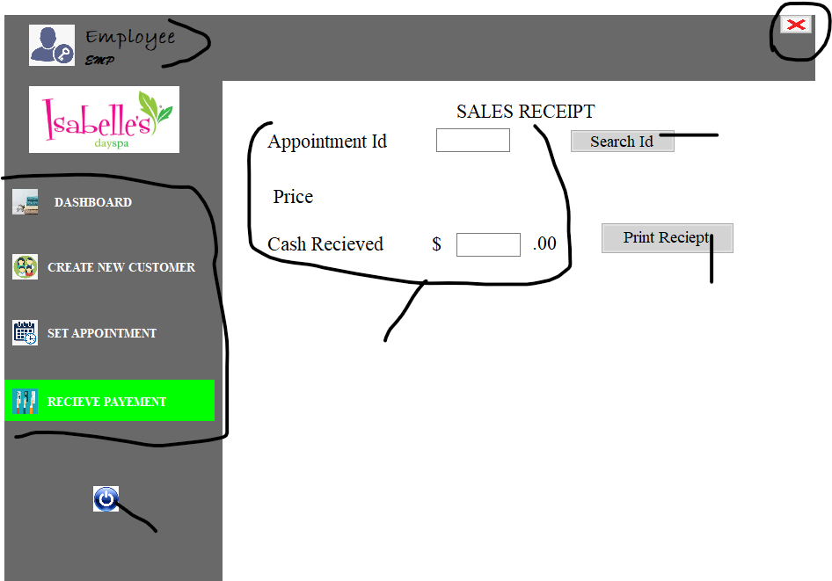

**4.**

**6.**

**5.**

**7.**

**3.**

**2.**

**1.**

1. Displays User NAME along with User LOGINNAME
2. Button: Used to CLOSE and EXIT application
3. Menu List: Highlight colour green shows that current form ACTIVE also it remains users where they are
4. TextBox: ENTER appointment Id to retrieve price, Enter Cash payed my customer
5. Button: CLICK button to SEARCH for the Id

ERROR occurred if appointment id does not exist to fix CHECK and REENTERED correct appointment Id

1. Button CLICK to PRINT Receipt after cash is collect and entered in the textbox

ERROR occurs If cash is not entered and application will crash to fix this restart application

1. Button: Used to LOGOUT or SIGNOUT users to the login in screen

SALES RECIEPT PRINT INTERFACE

Interface use to print sales reciept

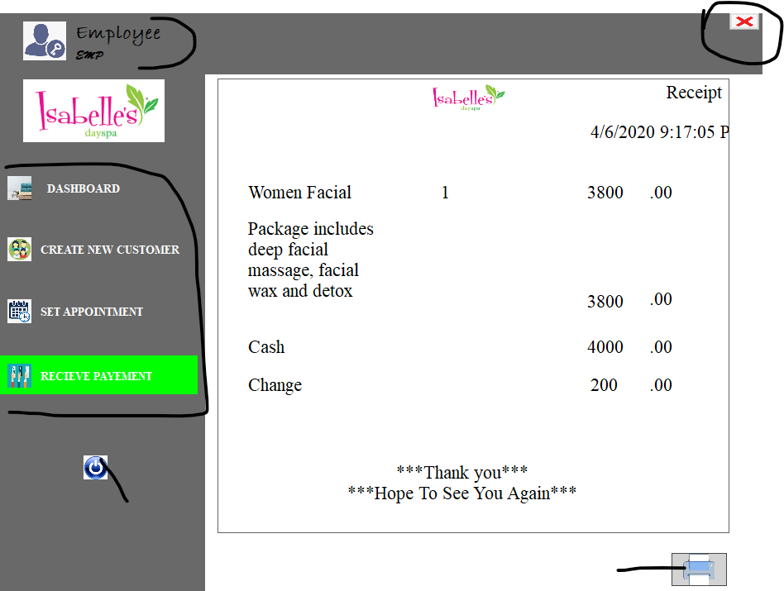

**4.**

**5.**

**6.**

**3.**

**2.**

**1.**

**v**

1. Displays User NAME along with User LOGINNAME
2. Button: Used to CLOSE and EXIT application
3. Menu List: Highlight colour green shows that current form ACTIVE also it remains users where they are
4. Sales RECEIPT FORMAT for printing
5. Button: CLICK button to PRINT sales receipt
6. Button: Used to LOGOUT or SIGNOUT users to the login in screen